**Project Planning 4**

**Demo**  
  
What you have done on the Project since last time?

-Drew the remaining 2 low fidelity sketches of our charts.

-Finished creating our pie chart.

-Improved all the charts and graphs to make it function perfectly.

-Finished designing our website.

-Finished writing the process book.

-Completed our project.

What you plan to complete before the next stand-up?

-Nothing left to complete

What obstacles you are facing in completing your deliverables?

-No more obstacles

**Submission**

***\*paste in text box on canvas***

List of what you have done since last standup.

-Drew the remaining 2 low fidelity sketches of our charts.

-Finished creating our pie chart.

-Improved all the charts and graphs to make it function perfectly.

-Finished designing our website.

-Finished writing the process book.

-Completed our project.

Link to our website: <https://cos30045ass2.netlify.app/homepage/>

**Images of our low fidelity sketches of our charts**

**LFS of our Bar Chart:**

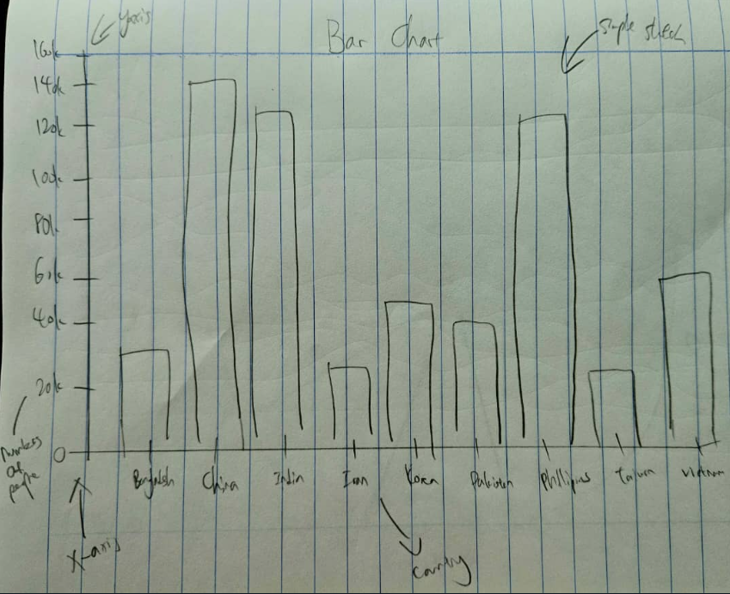

**LSF of our Pie Chart:**

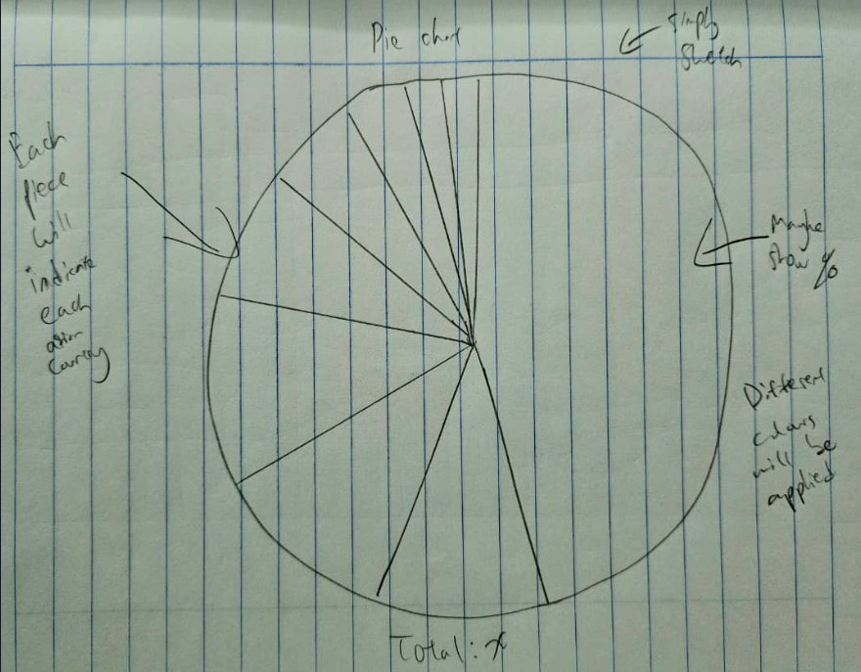

**Improved and completed our Bar Chart**

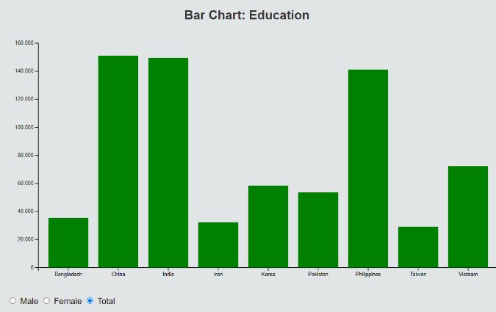

**Male**

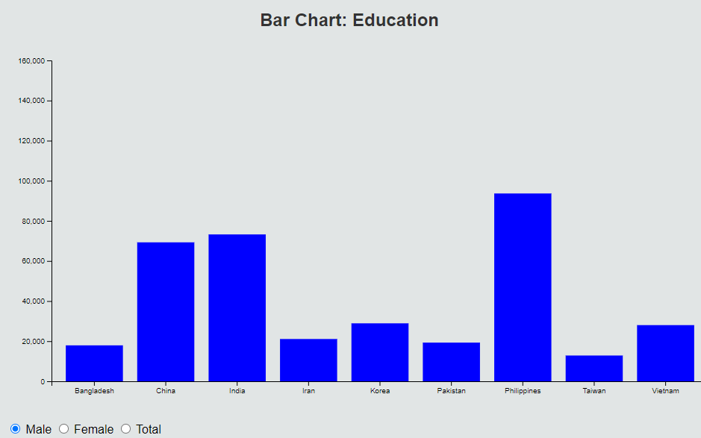

**Female**

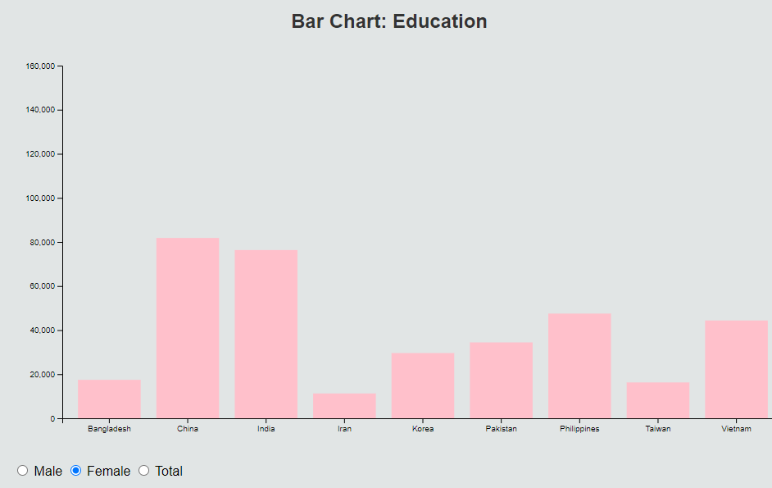

**Coding for the Bar Chart**

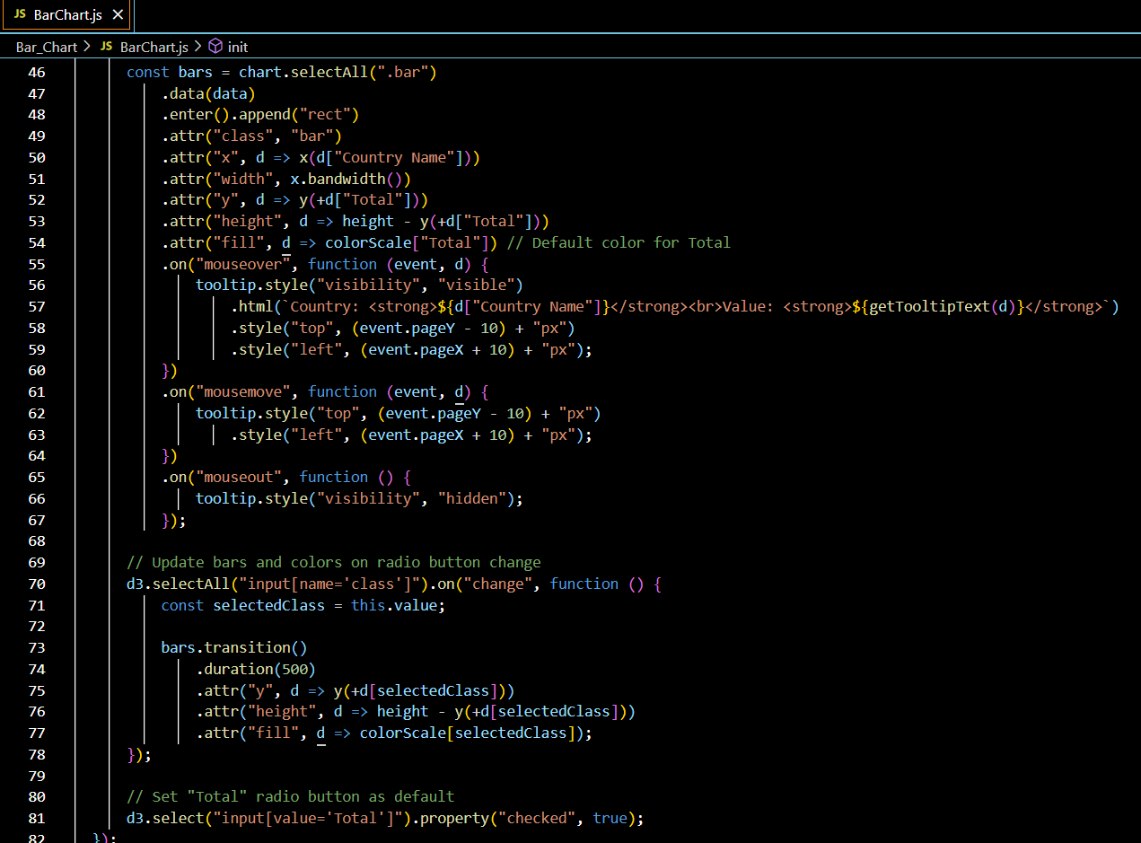

**Completed our Pie Chart**

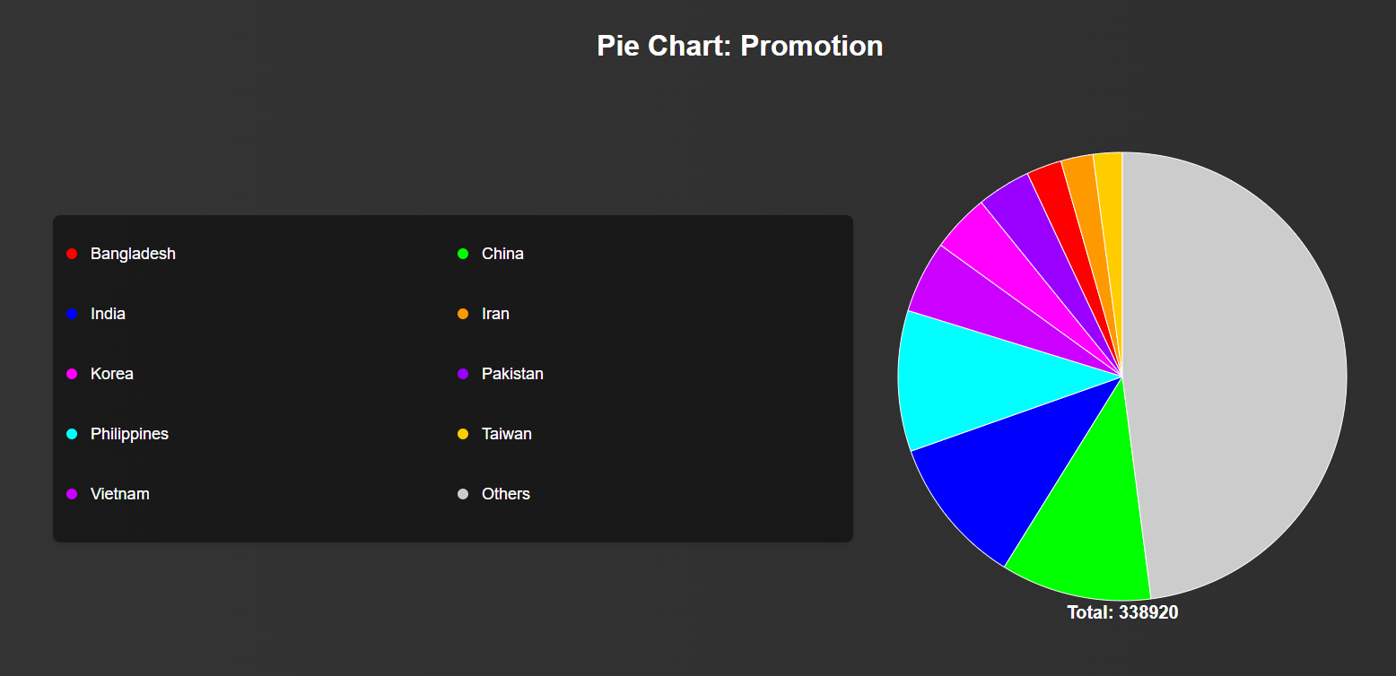

**Coding for the Pie Chart**

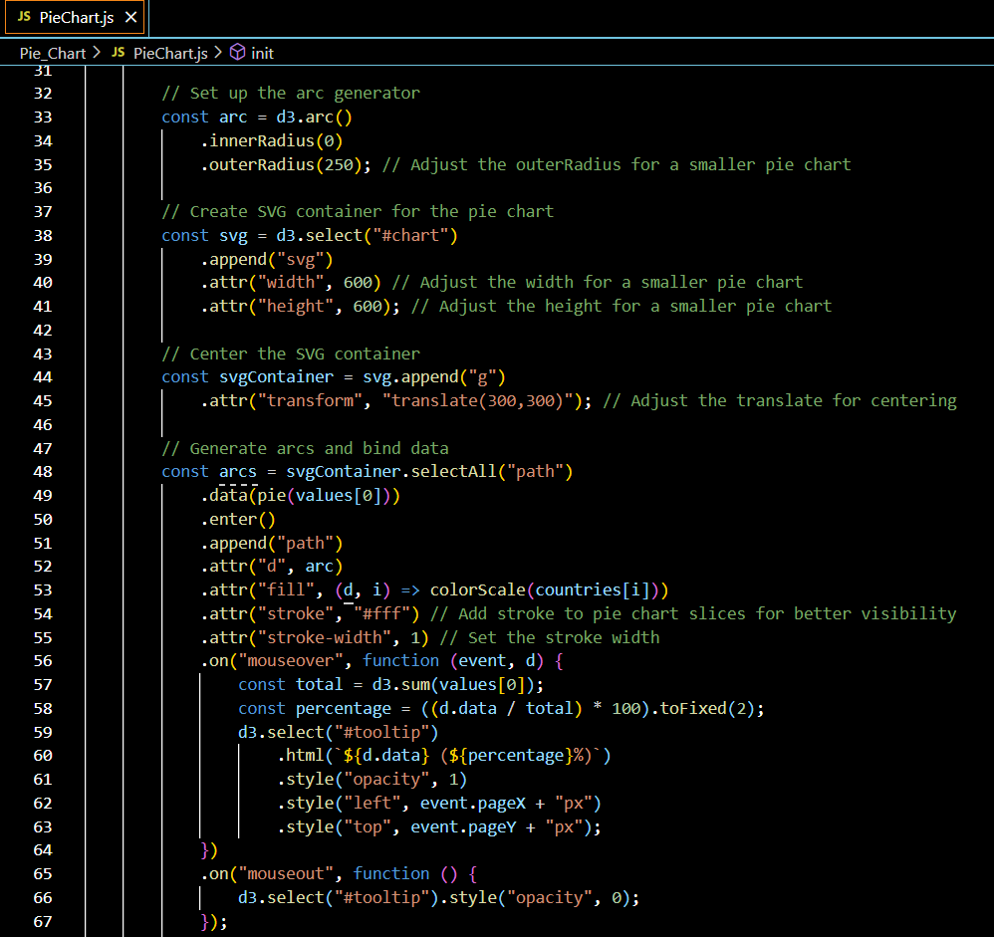

Estimate of your contribution (in hours and % of work completed by team so far) to:

|  |  |  |
| --- | --- | --- |
|  | Lam Mun Swee | Wan Zhen Yao |
| Finding and working with the data set | Time taken: 202 hours  Percentage of work completed: 90% | Time taken: 5 hours  Percentage of work completed: 10% |
| Designing the visualisation | Time taken: 5 hours  Percentage of work completed: 30% | Time taken: 11 hours  Percentage of work completed: 70% |
| Contributing to writing up the Process Book | Time taken: 4.5 hours  Percentage of work completed: 80% | Time taken: 2 hours  Percentage of work completed: 20% |
| Writing/researching code | Time taken: 7 hours  Percentage of work completed: 25% | Time taken: 13 hours   Percentage of work completed: 75% |

Summary of to-dos before next standup.

-Completed the project.

Any issues with teamwork.

No.